Swachh Bharat Abhiyan

As part of Swachh Bharat Mission and as per the directive of Ministry of Rural Development, Government of India, Kannamaly village in Ernakulam district was adopted under the Swachh Bharat Abhiyan. On World Fisheries Day on 21st November, 2015 a cleanliness drive was initiated at Ward No. 10 of Kannamaly. The Chellanam Panchayat President Smt. Mercy Joshy, Kannamaly Block Member Smt. Pushpy Ponnan, Ward Member Shri Dineshan along with the local people participated in the programme. A 500 m stretch along side the coastal village was cleaned and plastic waste cleared from the premises. From the Institute Scientists, Technical Staff, Administrative Staff and Skilled Support Staff participated the Programme. Dr. V. Geethalakshmi, Principal Scientist & Nodal Officer, Swachh Bharat Abhiyan, ICAR-CIFT coordinated the programme.
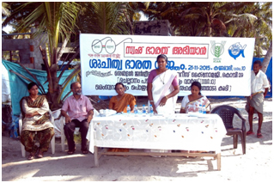
Inauguration of the programme
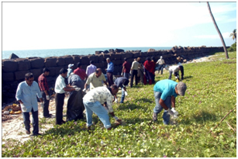
Swachh Bharat Abhiyan in progress

